**Smart Parking System**

**Project Specifications:**

1. System have three floors each floor have 4 parking slots.
2. 1 stepper motor for lift
3. 1 stepper motor is for rotate circular plate
4. 1 stepper motor is for slide car in and get back
5. 16x4 LCD display
6. 4x4 matrix key pad
7. RFID reader

**Working Flow:**

**\*Car parking flow:**

1. user park car on platform circular disk
2. user scan his RFID card
3. system find out if there is any empty parking slot available
4. system show parking slot available
5. user select vehicle type
6. user enter how much time he wants to park car(day/hours/minute)
7. display show charges for parking
8. system reduce money for that user RFID card
9. lift moves down and got to vehicle type floor (eg. Four wheelers)
10. circular disc rotate to direction of parking slot.
11. Car is slide to parking slot
12. lift come to its position back

**\*****Car unparking flow:**

1. user scan his RFID card
2. system shows how much time vehicle spend in parking slot
3. if it more than user entered then user need to pay extra charge
4. if extra charge then money deduct for that RFID card
5. lift find slot for vehicle of that RFID card
6. rotate disk move to slot direction sliding motor slides vehicle on disk
7. lift come to its position back.

**\*Recharge RFID:**

1. Admin swap his RFID card
2. enter amount to be recharge
3. swaps users RFID to recharge

**If Car time Expired:**

1. If master card swap
2. show time expired cars.
3. Select car
4. Car unpacking flow

**Block Diagram:**

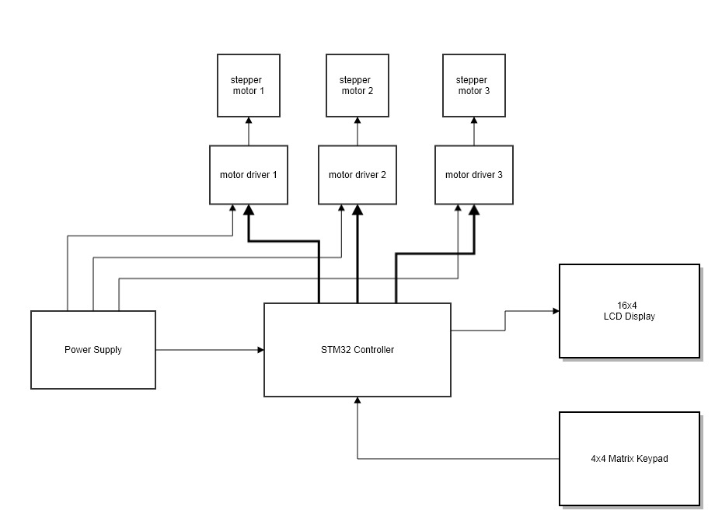

**Note:**

**Done by me:**

1. firmware coding for only system to be work as mention above.
2. Documentation – flow diagram, flow chart, block diagram, algorithm flow, data sheets, schematics , source code.
3. PCB designing and manufacturing.
4. only possible help for fix motors in mechanical design.

**Not to be done by me:**

1. No mechanical design or any mechanical part is created by me.
2. No any mechanical modifications will be done by me.